**Topology Generation of Shoe Midsole Lattice Structures for Rapid Manufacturing**

Name: Chan Ka Ching

UID: 3035838559

Course: DESN3002

**Abstract:**

This report explores the topology generation of shoe midsole lattice structures for rapid manufacturing. Structural lattices, which are cellular structures with repeated patterns, offer unique mechanical properties, including a high strength-to-weight ratio and the ability to conform to surfaces. The study aims to overcome the limitations of existing lattice structures used in shoe soles by employing conformal lattice generation, density control curves, a diverse range of unit cell topologies. The research methodology involves scanning and identifying variables, generating designs, evaluating and optimizing them through finite element analysis, and materializing the optimized design using 3D printing. The resulting lattice structures are evaluated based on comfort, function, and fabrication criteria. The project finds that unit cells with strut-based topologies exhibit better performance in terms of deformation and displacement, with the lattice structure featuring a body-centered cubic BCC plus Z strut topology being the strongest among all the designs.

**1. Introduction**

The use of structural lattices in various applications has gained attention due to their potential for lightweight and strong designs. In recent years, there has been a greater emphasis on using lattice structures in shoe midsoles. The development of additive manufacturing, particularly 3D printing, has permitted the quick creation of complicated lattice structures, making it a perfect technique for producing shoe midsoles with elaborate lattice patterns. This study will look at the most recent research and breakthroughs in lattice structures for shoe soles, addressing the constraints of current designs and offering novel techniques to topology creation.

**2. Structural Lattices: Definition and Properties**

Structural lattices are cellular structures composed of repeated patterns known as unit cells that naturally exist in the environment such as in honeycombs, leaves, tree trunks and animals bones.

Lattices possess unique mechanical properties, including a high strength-to-weight ratio and the ability to conform to surfaces. These characteristics make them particularly suitable for applications such as shoe midsoles, where lightweight and strong designs are desired.

**3. Conformal Lattice Structures**

The capacity of conformal lattice structures to accept intricate, curved surfaces has emerged as a significant development in the field of lattice design. Conformal lattices have distinct advantages over regular uniform lattices, which are usually made for flat surfaces. These advantages include strength and design adaptability.

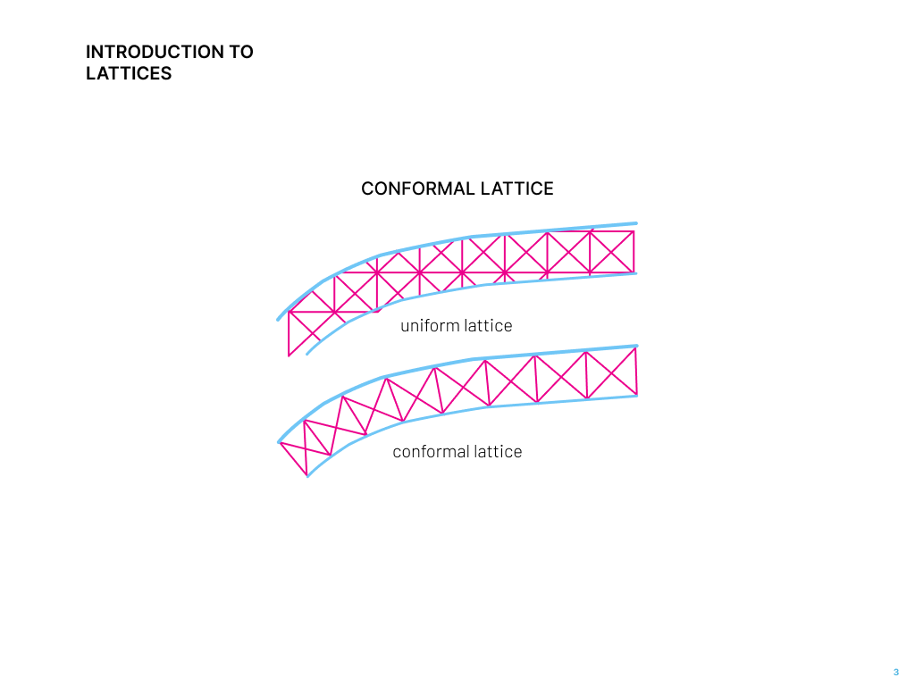

**Fig. 1.** Uniform lattice versus conformal lattice

In a traditional uniform lattice, the unit cells are periodically arranged in space regardless of the outlines of the macrostructures. Cells in different locations share the same element size and topology. Contrarily, the unit cells in a conformal lattice vary in shape and size and can fit perfectly along the surfaces. This is much better because the distribution of nodes in uniform lattice structures is fixed in space, and unnecessary need to be trimmed off according to the shape of the surface. This is, however, needless for the conformal lattice, which means it allows for more complicated designs involving irregular surfaces and can be used to stiffen or strengthen the complex, curved surfaces such as in shoe soles. A shoe sole consists of three parts — the insole, midsole, and outsole. The insole is the upper part touching the body of the shoe, the outsole is the part in touch with the ground and the midsole is the part sandwiched in-between, which we can fill using the conformal lattice structure.

Moreover, the development of additive manufacturing, specifically 3D printing, has made it easier to fabricate conformal lattice structures that are highly complex and precise. Through the utilization of 3D printing technology, complex lattice patterns may be produced that meet the specific mechanical qualities and performance requirements while also adapting to the unique shapes of the foot. This degree of adaptability and customisation creates new opportunities for individualized footwear solutions that satisfy different requirements and tastes. Beyond support and comfort, conformal lattice constructions have other advantages. Additionally, these structures may provide better impact resistance and energy absorption. During walking or running, the midsole may efficiently absorb and release energy by aligning its lattice pattern with the foot's natural movement and load distribution. This reduces the likelihood of injuries and improves overall performance.

**4. Precedents and Research Gaps**

I first realized that lattice structures can be used at various scales, such as steel lattice-shell structures in large-scale constructions, truss structures in bridges, medium-sized, 3D-printed lattice pavilions, or even tiny pieces of furniture. Midsole-wise, I discovered that Adidas and other research teams have already investigated the use of lattice frameworks. The majority of them focused on the four most frequent types of unit cell topologies, which are typically included with Grasshopper plugins such as Crystallon or Intralattice. Past research publications also branch out by focusing on a certain unit cell type and studying variations of it, or by looking at strut diameter and other characteristics. Hence, I discovered that a prevalent constraint is the absence of diversity in unit cell tpologies and density. By expanding the range of lattice cell types and density variations, my project can uncover optimal configurations that maximize comfort and performance in shoe midsoles.

**5. Research Objectives**

The research objectives of this study are to explore the use of conformal lattice generation, density control curves, a diverse range of unit cell topologies, and incorporate additional research findings in the field of lattice structures for shoe midsoles. The methodology involves scanning foot models to identify variables, generating lattice designs, evaluating their performance through finite element analysis, and materializing the optimized design using 3D printing. The research methodology integrates insights from previous research to develop an improved approach for topology generation in shoe midsole lattice structures.

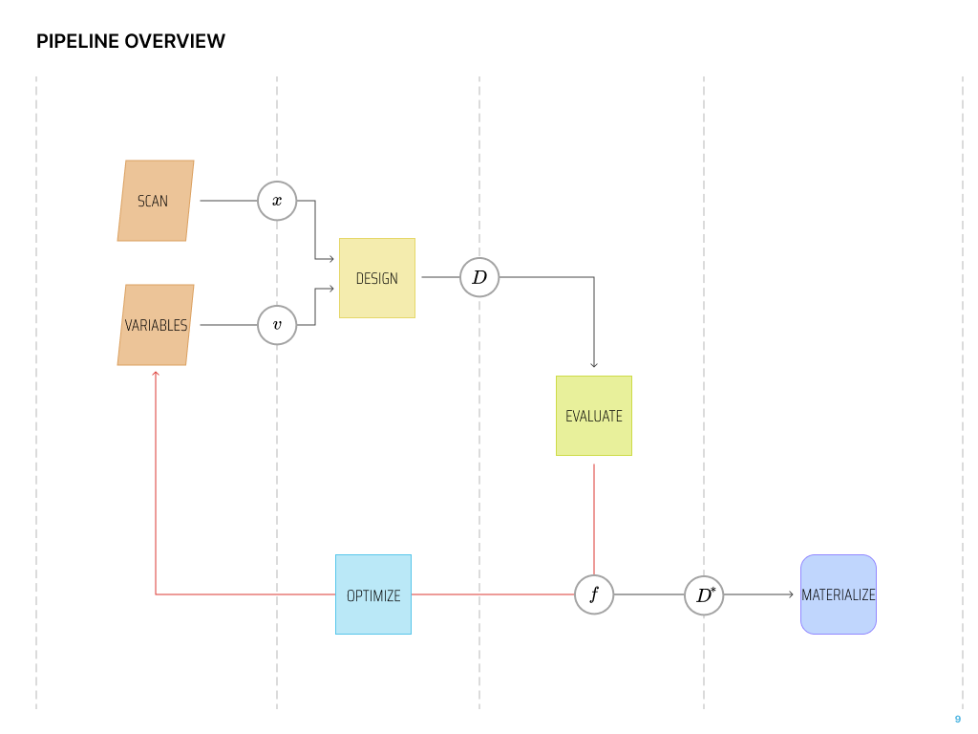

**Fig. 2.** Pipeline Overview

**6. Methodology**

The methodology employed in this study comprises several key steps, each playing a crucial role in the development and optimization of lattice structures for shoe midsoles. These steps include scanning and setting variables, design generation, evaluation, optimization, and materialization.

Specifically, using the Rhino mobile app, I scanned a 3D model of my foot, which I used as a basis for forming sole surfaces. Then I identified my variables as the number of cells in XYZ directions, adjustable curves for controlling relative spacing and unit cell topologies. I then used the sole surfaces to generate a conformal lattice, which consists of a 3D grid of twisted boxes controlled by the variables. And from here, I can map my library of unit cell topologies into the boxes. The evaluation phase of the methodology focuses on assessing the geometry and fabrication performance of the generated lattice structures before inserting the best results into the second phase of structural finite element analysis using Karamba in Grasshopper. Finite element analysis (FEA) is utilized to simulate and analyze the structural behavior of the lattice midsoles. Through FEA, this study can examine various factors such as deformation, displacement, and stress distribution within the lattice structure. Based on this, I iteratively optimized the filtered set of designs until the automated and parametric system produced the best design that matched the requirements. This iterative process involves adjusting parameters such as lattice density, cell size, and geometry to achieve the desired performance outcomes.

Lastly, at the materialization stage, the optimal lattice designs are realized using 3D printing technology. The intended result was to use thermoplastic polyurethane (TPU) to reproduce the elastic, abrasion-resistant, lightweight and comfortable properties for a desired midsole. 3D printing also allows for the precise and economical manufacture of complicated lattice designs.

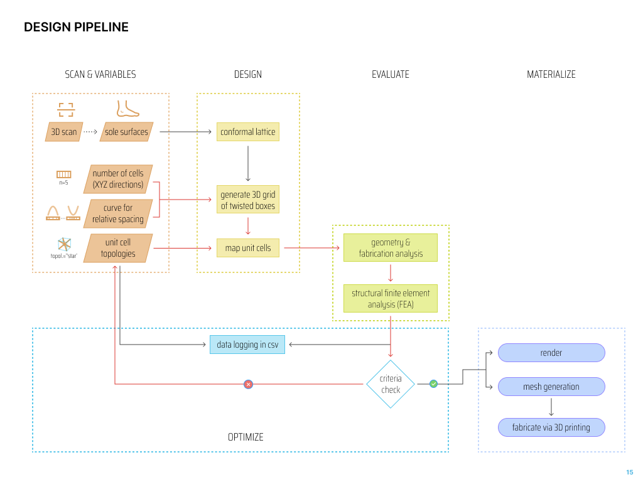

**Fig. 3.** Design Pipeline

**7. Construction of Lattice Structures**

Using Grasshopper, a source surface and destination surface were constructed, enabling the lattice structure to conform between the two. To modify the density, a curve was incorporated to control the relative spacing of cells in the lattice structure. When the curve changes to a downward parabola, the midsole becomes denser on the side and more dispersed in the center. In the same logic, an upward parabola shapes the sole into becoming denser in the center and more spaced on the sides.

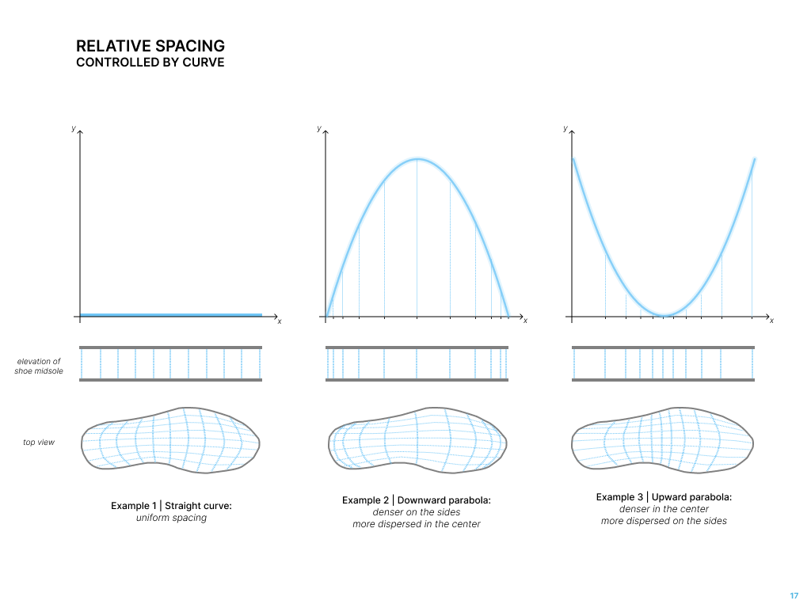

**Fig. 4.** Relative Spacing Controlled By Curve

Once this was completed, a library of unit cells was created. The top two rows consist of collections of pre-existing lattice structures commonly employed in lattice structures overall. The subsequent rows showcase variations of existing topologies or the addition of struts to enhance structural stability.

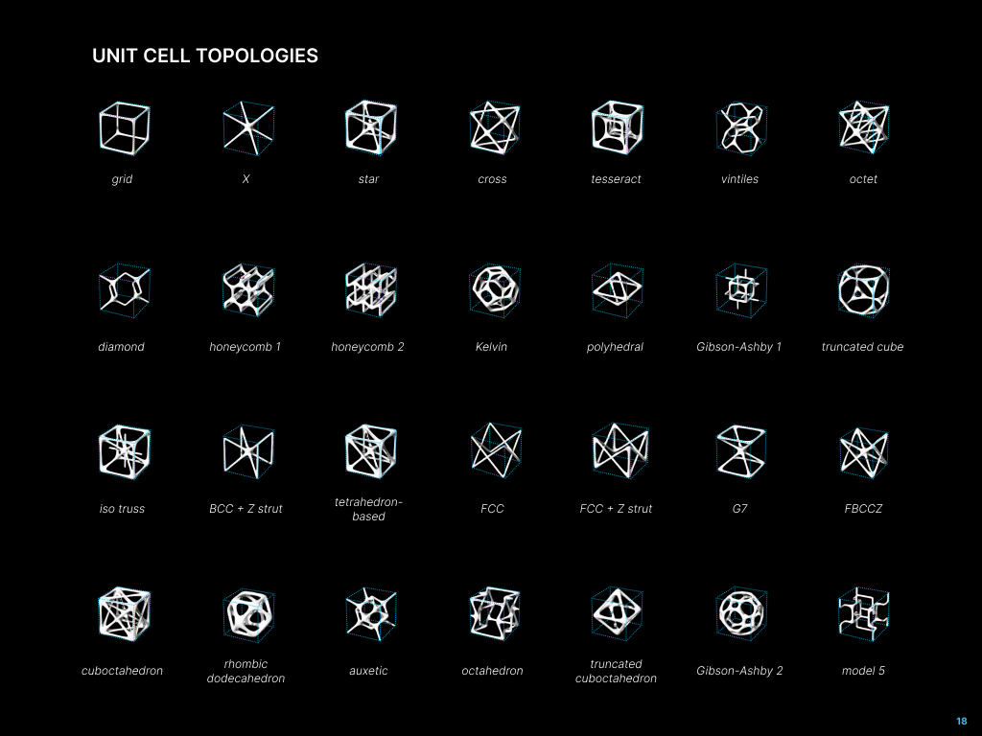

**Fig. 5.** Exploration of Unit Cell Topologies

**8. Evaluation Criteria**

After considering the variables relevant to my project, it is essential to establish evaluation criteria to assess the effectiveness of the designed lattice midsoles. Several key factors are taken into account to ensure optimal performance.

Now, moving on to the evaluation criteria that have been established. When considering the midsole for shoes, the top priorities are comfort and health, which are assessed based on the uniform stress and uniform deformation data generated through Karamba. Additionally, the functionality of the design for various purposes is taken into account. The final criterion is fabrication, which involves analyzing the basic geometry of the designs using four methods. Intuitively, it is understood that, for the sake of ease in fabrication, efforts should be made to minimize the total number of edges or complexity, reduce the number of edges that are excessively short or long to avoid evident weak points in the structure, minimize the difference in area to ensure that the midsole outline aligns with the curvature of the target surface, and minimize runtime.

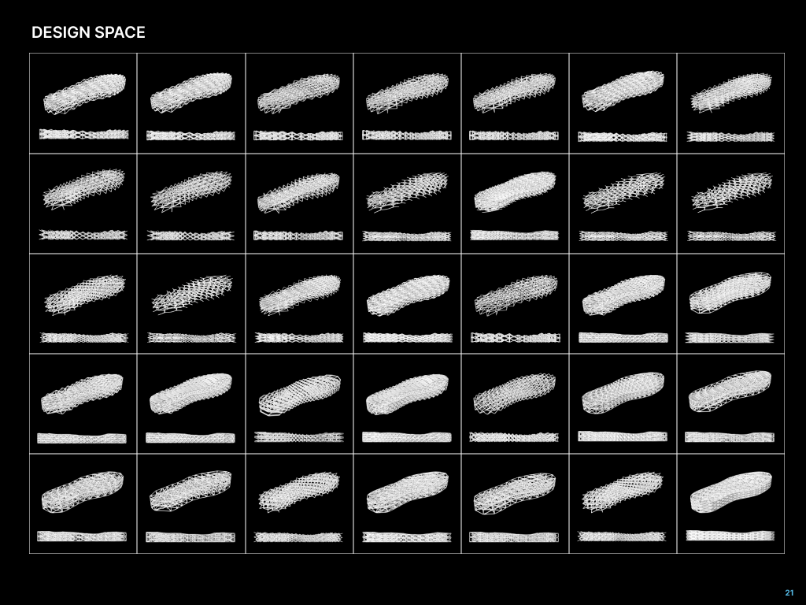

**Fig. 6.** Design Space

Utilizing the fabrication criteria, numerous designs were generated and presented in the design space. The scores from each sub-criteria under fabrication were added together to get the top 35 scores that align most effectively with the fabrication objectives. Interestingly, these options encompassed only a limited selection of the commonly employed topologies for shoe midsoles. Subsequently, the obtained results were incorporated into Karamba for structural analysis. The simulation models, each assigned a master surface and slave surface, were examined, and displacement load and boundary conditions were applied to replicate real-life scenarios of when a person steps onto the shoe sole.

**9. Discussion of Results**

The findings from the study not only confirm the efficacy of conformal lattice structures in enhancing comfort and performance in shoe midsoles but also shed light on the superior mechanical performance of strut-based topologies. Through a comprehensive analysis using finite element analysis (FEA), the study reveals that lattice structures with strut-based designs outperform other alternatives, making them a viable choice for optimizing shoe midsole performance.

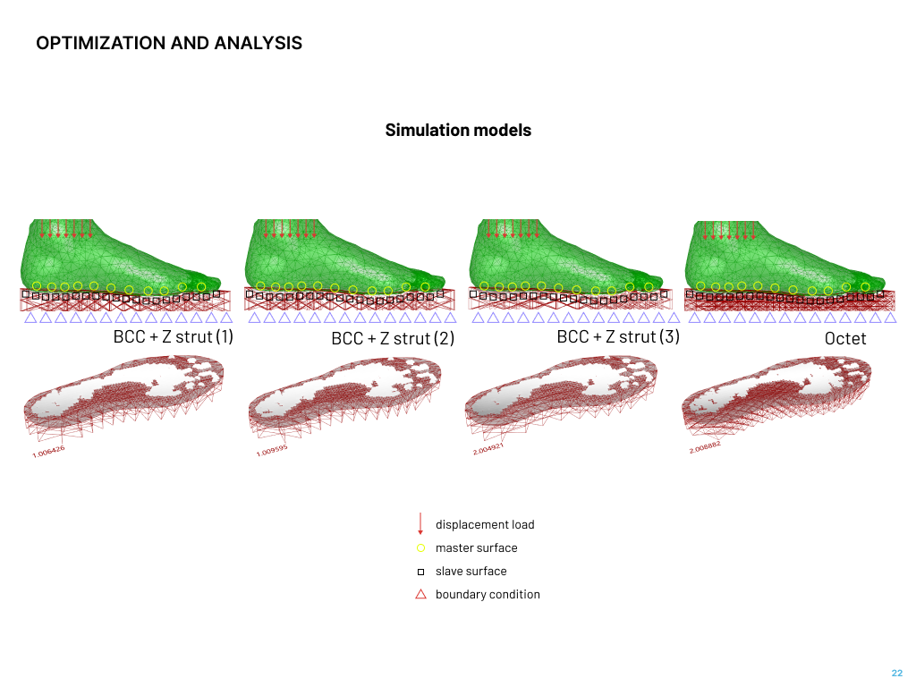

**Fig. 7.** Simulation Models of Displacement

With the reaction force being the same, the rounder, more polyhedral and truncated unit cells have greater deformation, perhaps due to the lack of structural connection between the repeating cells. On the other hand, unit cells with more strut-based topologies have much less deformation.

Also, the traditionally well-performing grid topology is seen to have greater displacement and strain energy that the other less commonly used ones. Among the various strut-based lattice structures tested, the body-centered cubic (BCC) with Z strut topology emerges as the most promising design. This topology exhibits exceptional strength and stiffness, surpassing other tested lattice structures in terms of mechanical performance. The Z struts in the topology enhances its performance by adding an additional level of stability and structural reinforcement to the lattice design. Through interconnecting the struts diagonally, the Z struts effectively resist deformation and promote load sharing across the lattice structure. This results in improved resistance to compression, tension, and bending forces, ultimately enhancing the lattice midsole's overall mechanical performance.

**10. Limitations**

Despite the study's positive findings and developments, significant limitations must be acknowledged when interpreting the data.

One of the study's shortcomings is that it considers symmetrical lattice configurations. While symmetrical designs are simple and easy to analyze, they may not convey the intricacy and individuality of each foot. In actuality, feet frequently display asymmetrical traits such as arch height, foot form, and pressure distribution. Another constraint is the various topologies of the sections within the lattice midsole. The study employed a specific strut topology, the body-centered cubic (BCC) plus Z design, as its principal lattice arrangement. However, various parts of the midsole may require different lattice topologies to work well. For example, the heel region may benefit from a different lattice structure than the forefoot or arch area. Future research should focus on the creation of hybrid lattice structures with various topologies inside different portions of the midsole to ensure overall performance increase.

The precision of the foot model employed in the study is another drawback. Although sophisticated scanning techniques were used to gather geometric data such as foot form, arch height, and pressure distribution, the foot model may still have intrinsic limits in terms of accuracy and precision. Scanning resolution, motion artifacts, and differences in foot posture while scanning can all cause problems. To address this issue, future research should aim to improve scanning methodology and data collecting techniques in order to increase the accuracy of the foot model and assure a more accurate depiction of real-world foot features.

Additionally, the impact of various stances on lattice midsole performance should be addressed. The study was primarily concerned with assessing the mechanical performance of the lattice midsole in the middle stance or the neutral standing position. However, foot biomechanics and load distribution can change greatly depending on the activity, such as walking, running, or jumping. Future studies should include a larger range of postures and movements to fully evaluate the lattice midsole's efficacy under different dynamic settings. Addressing these limitations in future research will result in more accurate and comprehensive assessments, allowing for the development of next-generation lattice midsoles that cater to the unique characteristics and performance requirements of individual feet in a variety of activities and positions.

**11. Potentials**

Despite the limitations highlighted above, the study's findings provide fascinating opportunities for additional investigation and prospective uses of conformal lattice structures in shoe midsole design.

One area of possible progress is the use of 3D-printing technology, notably thermoplastic polyurethane (TPU) materials, to manufacture lattice midsoles. 3D printing provides benefits in terms of customisation and adaptability, allowing the creation of lattice structures adapted to individual foot features and performance needs. TPU, recognized for its superior mechanical qualities, flexibility, and durability, is an appropriate material for developing lattice midsoles that improve comfort and performance. Further study can concentrate on refining 3D-printing process parameters, lattice geometries, and TPU material compositions to optimize the potential of lattice midsoles in customized footwear.

Another area of possibility is the incorporation of lattice structures into a variety of shoe kinds. While the study focused on midsoles, lattice structures may be applied in other shoe components such as insoles, outsoles, and even upper constructions. Each shoe type provides distinct problems and requirements, and the use of lattice structures can meet specific demands such as impact absorption, stability, and ventilation. Designers may improve overall footwear performance and meet the unique needs of different activities, sports, and lifestyles by investigating the use of lattice structures in various shoe kinds.

Furthermore, the prospective medicinal applications of lattice midsoles are worth researching. Lattice constructions have showed potential in offering support and comfort to people with specific foot issues including plantar fasciitis, flat feet, or high arches. The intrinsic flexibility and adaptability of lattice structures allows for tailored support and pressure redistribution, possibly reducing symptoms and enhancing foot health. Collaborations between footwear designers and medical practitioners can assist in identifying unique medical needs and developing bespoke lattice midsoles to meet individual foot issues, potentially increasing overall foot function and lowering the risk of associated accidents.